Charge Ball Suspended Near a Charged Sheet

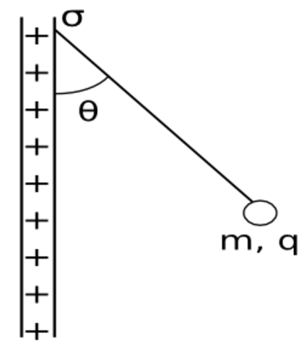**Question:** In the figure, a small, nonconducting ball of mass 12.0 mg with uniformly distributed charge 66.6 nC hangs at rest from an insulating thread that makes an angle 18.0° with a vertical, uniformly charged nonconducting sheet. Considering the ball's weight and assuming that the sheet extends far in all directions, calculate the surface charge density of the sheet.

Tension(T)

Tcosθ

θ

Tsinθ

Felectic

mg

Free Body Diagram

In order to find the charge density, σ, of the sheet we will need to use the following equation.

 The resulting field is half that of a conductor at equilibrium with this surface charge and therefore we divide by 2.

e0 the electric permittivity which is a constant of proportionality that exists between electric displacement and electric field intensity.

e0 = 8.854x10-12F/m.

Now we want to find σ so we will set the equation for charge density.



We have q which is the charge of the ball and which was also given, 6.66x10-8 C. What we have to do now is find F which we can find using some trig and Newton’s Third Law.

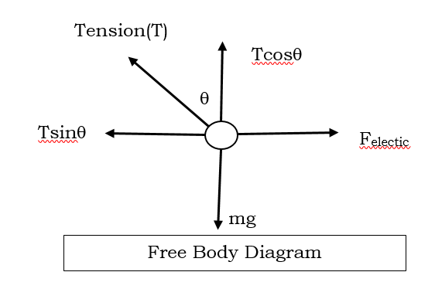From the free body diagram we can write

Felectric – Tsinθ = 0 & Tcosθ - mg = 0

Where Felectric  = qE;

From the first equation we can solve for T and then substitute it into the second equation.

We solved for the electric field and now we plug this back in to find the charge density, σ, and afterwards plug in all the values and solve.

$$=\frac{mgtan}{q} x 2 x e_{0}$$

$$=\frac{\left(1.2x{10}^{-5}kg\right)\left(9.8\frac{m}{s^{2}}\right)(\tan\left(18\right))}{6.66x{10}^{-8}C} x 2 x (8.854x{10}^{-12} \frac{F}{m})$$

$$=573.73 \frac{N}{C} x \left(1.770x{10}^{-11}\frac{F}{m}\right)$$

$$=0.00000001 \frac{C}{m^{2}}=1.00x{10}^{-8} \frac{C}{m^{2}}$$

The charge density of the sheet is around 1.00x10^-8 Coulombs for every squared meter.